**Lesson 6: Tangents and Rates of Change**

After completing this lesson, you should be able to

* discuss tangent lines in greater detail
* discuss average rates of change
* discuss instantaneous rates of change

**Commentary**

**Topics**

1. [Tangent Lines](https://content.umuc.edu/file/7bdece95-b196-4233-9313-aa904663b08e/1/MATH140-0909.zip/Modules/M2-Module_2/Lesson_6/S3-Commentary.html#I)
2. [Average Rates of Change](https://content.umuc.edu/file/7bdece95-b196-4233-9313-aa904663b08e/1/MATH140-0909.zip/Modules/M2-Module_2/Lesson_6/S3-Commentary.html#II)
3. [Instantaneous Rates of Change](https://content.umuc.edu/file/7bdece95-b196-4233-9313-aa904663b08e/1/MATH140-0909.zip/Modules/M2-Module_2/Lesson_6/S3-Commentary.html#III)

**1. Tangent Lines**

In lesson 1 of this module, we introduced the tangent line and rates of change and used numerical methods to estimate the slopes of tangent lines and rates of change. In the subsequent lessons, we defined limits and introduced a variety of strategies for computing them, including the Limit Principles and various theorems. Now that we have a variety of techniques and theorems to help us determine limits, we will revisit tangent lines and rates of change.

Definition 21: Slope of Secant Line

The **slope of the secant line** to the curve *y* = *f*(*x*) at the point *A*(*c*, *f*(*c*)) is given by

https://content.umuc.edu/file/7bdece95-b196-4233-9313-aa904663b08e/1/MATH140-0909.zip/Modules/M2-Module_2/Lesson_6/images/Definitn21.gif

**Figure 2.6.1  
Slope of Secant Line**

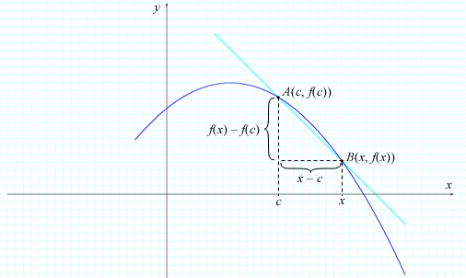

Geometrically, the slope of the tangent line is the limit of the secant slopes as the point *B* approaches the point *A* from either side. See figures 2.6.2a and 2.6.2b:

**Figure 2.6.2a  
Slope of Secants Approaching Slope of Tangent From Right**

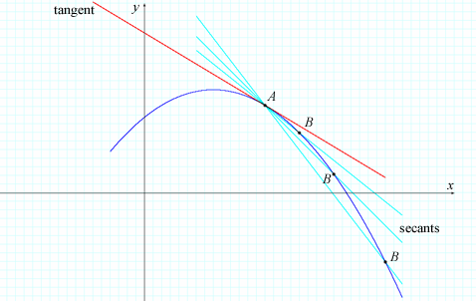

**Figure 2.6.2b  
Slope of Secants Approaching Slope of Tangent From Left**

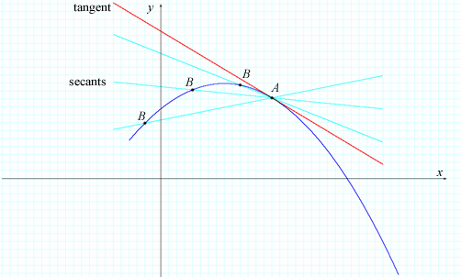

We write this geometrical interpretation using the following definition:

Definition 22: Slope of Tangent Line

The **slope of the tangent line** to the curve *y* = *f*(*x*) at the point *A*(*c*, *f*(*c*)) is given by

https://content.umuc.edu/file/7bdece95-b196-4233-9313-aa904663b08e/1/MATH140-0909.zip/Modules/M2-Module_2/Lesson_6/images/Definitn22.gif

provided the limit exists.

Recall that the point-slope equation of the tangent line passing through the point (*x*, *y*) with slope*m* is

*y* – *y* = *m*(*x* – *x*)

We use the point-slope form of a linear equation with *x* = *c*, *y* = *f*(*c*), and *m* = *m*tan to determine the equation of the tangent line at *A*(*c*, *f*(*c*)).

Definition 23: Tangent Line

The **tangent line** to the curve *y* =*f*(*x*) at *A*(*c*, *f*(*c*)) with slope *m*tan is given by the equation

*y* – *f*(*c*) = *m*tan(*x* – *c*)

**Exercise 2.6.1: Find an Equation of the Tangent Line I**

**Problem**

Find an equation of the line tangent to *y* = *x*2 at the point *A*(2, 4).

**Solution**

We use Definition 9 from lesson 4 to find the slope *m*tan given*c*= 2 and *f*(*x*) = *x*2:

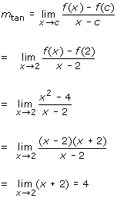

The equation of the line with slope 4 passing through point (2, 4) is

*y* – 4 = 4(*x* – 2), or *y* = 4*x* – 4

Figure 2.6.3 shows the graph of *y* = *x*2 and the tangent line at (2, 4):

**Figure 2.6.3  
*y* = *x*2 and Tangent Line at (2, 4)**

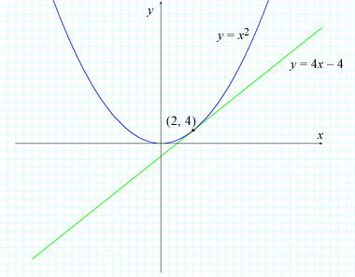

An alternative expression for the slope of the tangent line, obtained by taking *h* = *x* – *c* so that *x* = *h* +*c* and the slope of the secant line passes through points *A*(*a*, *f*(*a*)) and *B*(*a* + *h*, *f*(*a* + *h*)), is

https://content.umuc.edu/file/7bdece95-b196-4233-9313-aa904663b08e/1/MATH140-0909.zip/Modules/M2-Module_2/Lesson_6/images/Math140-mod2-lessn6-fig2-6-3-eq.gif

For *h* > 0, *B* is to the right of *A* (see figure 2.6.4). If *h* < 0, then *B* is to the left of *A*(not shown). As *B* approaches *A* (from either side) along the curve *y* = *f*(*x*),*h*approaches 0 and the secant line geometrically approaches the tangent line.

Hence, we can write the expression in Definition 9 as follows:

Alternative Expression for Slope of Tangent Line

https://content.umuc.edu/file/7bdece95-b196-4233-9313-aa904663b08e/1/MATH140-0909.zip/Modules/M2-Module_2/Lesson_6/images/Math140-mod2-lessn6-fig2-6-3-eq-altnatve.gif

Figure 2.6.4 shows the area to the right of *A*; when *h* < 0, then *B* approaches *A* from the left, with the same resulting tangent line at *A*.

**Figure 2.6.4  
*h* > 0**

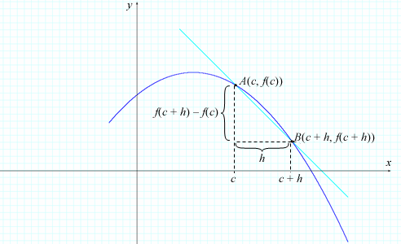

**Exercise 2.6.2: Find an Equation of the Tangent Line II**

**Problem**

Find an equation of the tangent line to the curve *y* = https://content.umuc.edu/file/7bdece95-b196-4233-9313-aa904663b08e/1/MATH140-0909.zip/Modules/M2-Module_2/Lesson_6/images/1-over-x.gif at the point *A*(2, https://content.umuc.edu/file/7bdece95-b196-4233-9313-aa904663b08e/1/MATH140-0909.zip/Modules/M2-Module_2/Lesson_6/images/one-half.gif).

**Solution**

In this example, *f*(*x*) =https://content.umuc.edu/file/7bdece95-b196-4233-9313-aa904663b08e/1/MATH140-0909.zip/Modules/M2-Module_2/Lesson_6/images/1-over-x.gif. The slope of the tangent line at (2, https://content.umuc.edu/file/7bdece95-b196-4233-9313-aa904663b08e/1/MATH140-0909.zip/Modules/M2-Module_2/Lesson_6/images/one-half.gif) is

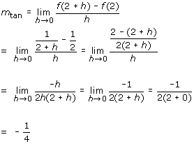

An equation of the tangent line at (2, https://content.umuc.edu/file/7bdece95-b196-4233-9313-aa904663b08e/1/MATH140-0909.zip/Modules/M2-Module_2/Lesson_6/images/1-half.gif) with slope –https://content.umuc.edu/file/7bdece95-b196-4233-9313-aa904663b08e/1/MATH140-0909.zip/Modules/M2-Module_2/Lesson_6/images/one-fourth.gif is

*y* – https://content.umuc.edu/file/7bdece95-b196-4233-9313-aa904663b08e/1/MATH140-0909.zip/Modules/M2-Module_2/Lesson_6/images/1-half.gif = –https://content.umuc.edu/file/7bdece95-b196-4233-9313-aa904663b08e/1/MATH140-0909.zip/Modules/M2-Module_2/Lesson_6/images/one-fourth.gif (*x* – 2), or *y* = –https://content.umuc.edu/file/7bdece95-b196-4233-9313-aa904663b08e/1/MATH140-0909.zip/Modules/M2-Module_2/Lesson_6/images/one-fourth.gif *x* + 1

Figure 2.6.5 shows a graph of the curve and the tangent line at *P*(2, https://content.umuc.edu/file/7bdece95-b196-4233-9313-aa904663b08e/1/MATH140-0909.zip/Modules/M2-Module_2/Lesson_6/images/1-half.gif).

**https://content.umuc.edu/file/7bdece95-b196-4233-9313-aa904663b08e/1/MATH140-0909.zip/Modules/M2-Module_2/Lesson_6/images/Math140-mod2-lessn6-fig2-6-5-figuretitle.gif**

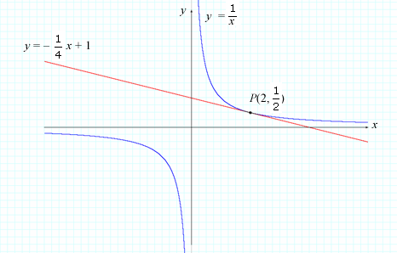

**Exercise 2.6.3: Find the Slope of a Tangent Line**

**Problem**

Suppose *y* = https://content.umuc.edu/file/7bdece95-b196-4233-9313-aa904663b08e/1/MATH140-0909.zip/Modules/M2-Module_2/Lesson_6/images/sqrt-x.gif.

1. Find the slope of the tangent line to the curve *y* = https://content.umuc.edu/file/7bdece95-b196-4233-9313-aa904663b08e/1/MATH140-0909.zip/Modules/M2-Module_2/Lesson_6/images/sqrt-x.gifat *x* =*c*(assuming *c* ≠ 0).
2. At what point is the slope of the tangent line equal to https://content.umuc.edu/file/7bdece95-b196-4233-9313-aa904663b08e/1/MATH140-0909.zip/Modules/M2-Module_2/Lesson_6/images/1-ovr-6.gif?

**Solution**

1. The slope of the tangent line at *x* =*c*(or the point *A*(*c*,https://content.umuc.edu/file/7bdece95-b196-4233-9313-aa904663b08e/1/MATH140-0909.zip/Modules/M2-Module_2/Lesson_6/images/sqrt-c.gif)) is

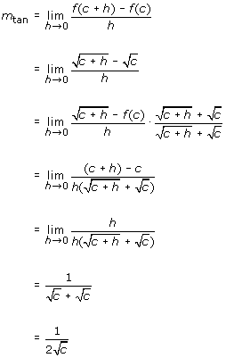

Thus, the slope of the tangent at *x* = *c* is https://content.umuc.edu/file/7bdece95-b196-4233-9313-aa904663b08e/1/MATH140-0909.zip/Modules/M2-Module_2/Lesson_6/images/Math140-mod2-lessn6-excr2-6-2-soltn3.gif.

1. To find where the slope of the tangent line is https://content.umuc.edu/file/7bdece95-b196-4233-9313-aa904663b08e/1/MATH140-0909.zip/Modules/M2-Module_2/Lesson_6/images/1-ovr-6.gif, we need to find the value of *c* for which https://content.umuc.edu/file/7bdece95-b196-4233-9313-aa904663b08e/1/MATH140-0909.zip/Modules/M2-Module_2/Lesson_6/images/Math140-mod2-lessn6-excr2-6-2-soltn3.gif= https://content.umuc.edu/file/7bdece95-b196-4233-9313-aa904663b08e/1/MATH140-0909.zip/Modules/M2-Module_2/Lesson_6/images/1-ovr-6.gif. Solving this equation, we find that *c* = 9 and that the point is *A*(9, 3).

Thus, the slope of the tangent to the curve *y* = https://content.umuc.edu/file/7bdece95-b196-4233-9313-aa904663b08e/1/MATH140-0909.zip/Modules/M2-Module_2/Lesson_6/images/sqrt-x.gif is https://content.umuc.edu/file/7bdece95-b196-4233-9313-aa904663b08e/1/MATH140-0909.zip/Modules/M2-Module_2/Lesson_6/images/1-ovr-6.gif at point *A*(9, 3).

**2. Average Rates of Change**

Suppose the position of an object at time *t* moving along a straight line is given by the function *f*(*t*). In other words, *f*(*t*) gives the **displacement** or *signed distance*from a fixed point, where *f*(*t*) < 0 implies that the object is a distance |*f*(*t*)| from a fixed point in the *negative direction*. For two positions *a*and *b* (*a* < *b*), the signed distance *f*(*b*) – *f*(*a*) represents the distance between the two positions *f*(*a*) and *f*(*b*). Using this notation, we can find the average velocity of an object.

https://content.umuc.edu/file/7bdece95-b196-4233-9313-aa904663b08e/1/MATH140-0909.zip/Modules/M2-Module_2/Lesson_6/images/Math140-mod2-lessn6-fig2-6-6a-average-vel-eq.gif

**Note This**

|  |  |
| --- | --- |
| https://content.umuc.edu/file/7bdece95-b196-4233-9313-aa904663b08e/1/MATH140-0909.zip/Modules/M2-Module_2/Lesson_6/images/NoteThisIcon.png | **Velocity** is the speed and direction an object is moving. |

We observe that the expression for average velocity is the same for the slope of the secant line.

Figure 2.6.6a shows the average velocity along a straight line from time *t* = *c* to time *t* = *c* + *h*.

**Figure 2.6.6a  
Average Velocity From *t* = *c* to *t*=*c*+ *h***

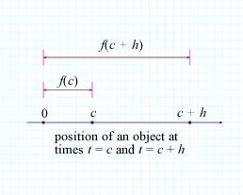

In the figure above, you can see that the average velocity = https://content.umuc.edu/file/7bdece95-b196-4233-9313-aa904663b08e/1/MATH140-0909.zip/Modules/M2-Module_2/Lesson_6/images/Math140-mod2-lessn6-fig2-6-6a-avr-vel-eq.gif.

Figure 2.6.6b shows the slope of the secant line *AB*.

**Figure 2.6.6b  
Slope of Secant Line *AB***

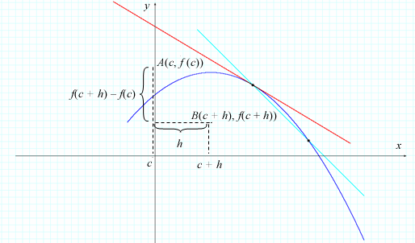

The slope of secant line*AB* = https://content.umuc.edu/file/7bdece95-b196-4233-9313-aa904663b08e/1/MATH140-0909.zip/Modules/M2-Module_2/Lesson_6/images/Math140-mod2-lessn6-fig2-6-6a-avr-vel-eq.gif = average velocity.

Velocity is one example of a rate of change. In general, if the rate of change is a value that depends on *x*, we can write *y* = *f*(*x*).

Definition 24

The **average rate of change of *y* with respect to *x*** is the expression

https://content.umuc.edu/file/7bdece95-b196-4233-9313-aa904663b08e/1/MATH140-0909.zip/Modules/M2-Module_2/Lesson_6/images/Definitn24.gif

where the notation Δ*y* is the **increment of *y*** (from *y*1 = *f*(*x*1) to *y*2 = *f*(*x*2)), and Δ*x* = *x*2 – *x*1 is the **increment of *x*** (from *x*1 to *x*2).

**3. Instantaneous Rates of Change**

In our consideration of average velocities over decreasing time intervals [*c*,*c*+*h*]—that is, in our consideration of average velocities as *h* approaches 0—we are now ready for the following definition:

Definition 25

Suppose *f*(*t*) represents the position of an object traveling along a straight line at time *t*. The **instantaneous velocity** at time*t* =*c*is

https://content.umuc.edu/file/7bdece95-b196-4233-9313-aa904663b08e/1/MATH140-0909.zip/Modules/M2-Module_2/Lesson_6/images/Definitn25.gif

provided the limit exists.

**Exercise 2.6.4: Determine the Velocity of a Falling Object**

**Problem**

Recall from Exercise 2.1.2 in lesson 1 that we dropped a penny from the Baltimore World Trade Center, which at 423 feet is the world's tallest equilateral five-sided building.

1. Determine the velocity of the penny two seconds after it was dropped from the top of the Baltimore World Trade Center.
2. Determine the velocity of the penny three feet before it hit the ground.

**Solution**

1. Recall that the distance in feet of a free–falling object at time*t*is *s* = *f*(*t*) = 16*t*2.

We use Definition 9 from lesson 4 to help us find a general expression for the instantaneous velocity *v*(*c*) after*c*seconds (i.e., at time *t* = *c*).

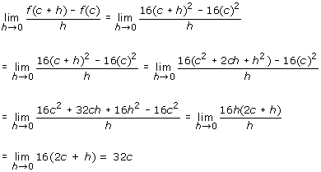

Hence, the instantaneous velocity after two seconds is given by

*v*(2) = 32(2) = 64 ft/sec

1. As the Baltimore World Trade Center is 423 feet high, the penny had traveled a total distance of 423 – 3 = 420 feet when three feet from the ground. To find the instantaneous velocity of the penny after it traveled 420 feet, we need to find the amount of time *t* the penny traveled (the distance of 420 feet):

*f*(*t*) = 16*t*2 = 420

Solving for *t*(*t* > 0),

https://content.umuc.edu/file/7bdece95-b196-4233-9313-aa904663b08e/1/MATH140-0909.zip/Modules/M2-Module_2/Lesson_6/images/Math140-mod2-lessn6-excr2-6-4b-soltn.gif

Thus, the velocity of the penny three feet before it hit the ground was

*v*(5.12) = 32(5.12) = 163.84 feet/sec

**Exercise 2.6.5: Find Average and Instantaneous Rates of Change**

**Problem**

Table 2.6.1 shows an estimation of the number of individuals arrested *A*(*t*) for driving under the influence of alcohol as a function of age*t*. (This projection is based on information from the National Highway Traffic Safety Administration [NHTSA], although the figures are made up for the purposes of this exercise.) Use the data in the table to

1. Find the average rate of change in the arrests (per 100,000 individuals) made for driving under the influence of alcohol between 18 and 26.
2. Estimate the instantaneous rate of change for age 40, and analyze your answer.

**Table 2.6.1  
Individuals Arrested for Drunk Driving as a Function of Age**

|  |  |
| --- | --- |
| **Age (*t*, years)** | **Number of Arrests (*A*(*t*), per 100,000)** |
| 14 | 113.00 |
| 16 | 308.77 |
| 18 | 421.32 |
| 20 | 485.32 |
| 22 | 519.13 |
| 24 | 534.54 |
| 26 | 537.99 |
| 28 | 533.67 |
| 30 | 524.25 |
| 32 | 511.47 |
| 34 | 496.52 |
| 36 | 480.17 |
| 38 | 462.97 |
| 40 | 445.30 |
| 42 | 427.40 |
| 44 | 409.45 |
| 46 | 391.59 |
| 48 | 373.89 |
| 50 | 356.41 |
| 52 | 339.18 |
| 54 | 322.23 |
| 56 | 305.57 |
| 58 | 289.21 |
| 60 | 273.14 |

**Solution**

1. From 18 to 26, the number of arrests (per 100,000) for driving under the influence of alcohol changes from 421.32 to 537.99, and so

Δ*A* = *A*(26) – *A*(18) = 537.99 – 421.32 = 116.67

for a change in age

Δ*t*= 26 – 18 = 6

Thus, the average rate of change in the number of arrests (per 100,000) for those between 18 and 26 is

https://content.umuc.edu/file/7bdece95-b196-4233-9313-aa904663b08e/1/MATH140-0909.zip/Modules/M2-Module_2/Lesson_6/images/Math140-mod2-lessn6-excr2-6-5-a-soltn.gif

Figure 2.6.7a gives a geometric interpretation.

The average rate of change between 18 and 26 years equals the slope of the secant line *AB*.

**Figure 2.6.7a  
Average Rate of Change in Drunk Driving Arrests, Age 18 to 26**

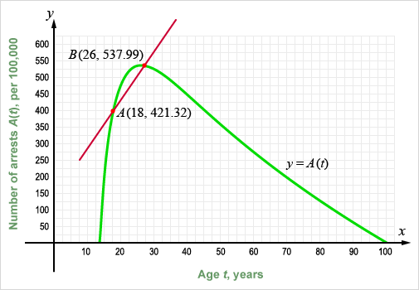

1. To estimate the instantaneous rate of change at 40, we need to examine the slopes of the two nearest secant lines to 40 (see figure 2.6.7b) associated with the two nearest ages to the left and to the right of 40.

**Table 2.6.2  
Slopes of Two Nearest Secant Lines to 40**

|  |  |  |
| --- | --- | --- |
| ***A*** | ***B*** | ***mAB*** |
| (38, 462.97) | (40, 445.30) | –8.835 |
| (42, 427.40) | (40, 445.30) | –8.950 |

**Figure 2.6.7b  
Two Nearest Secant Lines to 40**

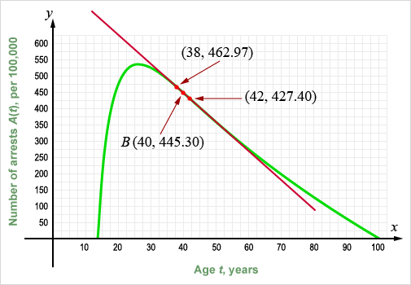

The slope of the tangent line at age 40 lies somewhere between –8.835 and –8.950. As in Exercise 2.1.3 of lesson 1, we use the average of the slopes of the two nearest secant lines to estimate the slope of the tangent line (which equals the instantaneous rate of change at 40):

instantaneous rate of change at https://content.umuc.edu/file/7bdece95-b196-4233-9313-aa904663b08e/1/MATH140-0909.zip/Modules/M2-Module_2/Lesson_6/images/instant-rate-eq.gif

Thus, at the age of 40, arrests *decrease* by approximately 8.893 (per 100,000) for driving under the influence.

As we can see in the table and figure above, the two secant lines have nearly the same slope. Because the slopes of the two nearest secant lines are so similar, we are assured that this is a reasonable estimate.

We can use an alternative strategy to find the instantaneous rate of change. By plotting the ordered pairs (*t*, *A*(*t*)) from table 2.6.2 and connecting the points using a smooth curve, we can sketch a rough representation of the graph of the function *y* = *A*(*t*). Using a strategy similar to the one described in Exercise 2.3.1 in lesson 3, we construct the tangent line at *B*(40, 445.30) and approximate the measure of the lengths of the sides of triangle *ABC*. The tangent line slopes downward from left to right; thus, it has a negative slope.

The slope of the tangent line at point *B* is approximated by

https://content.umuc.edu/file/7bdece95-b196-4233-9313-aa904663b08e/1/MATH140-0909.zip/Modules/M2-Module_2/Lesson_6/images/slope-tang-line.gif

The instantaneous rate of change at 40 equals the slope of the tangent line at *B*(40, 445.30). See figure 2.6.8:

**Figure 2.6.8  
Tangent Line at *B*(40, 445.30)**

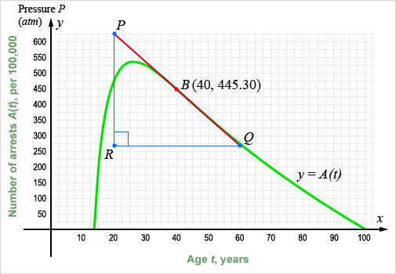

Many situations and disciplines call for finding rates of change (average and instantaneous). In physics, we might need to find the velocity of an object, or the rate of change the object has traveled with respect to time. In business, we might need to find the rate of change of revenue earned from producing *x* items per unit of time with respect to *x* (called the *marginal revenue*).

In medicine, we might need to find the rate at which a drug is absorbed into the bloodstream with respect to time. In actuarial sciences, we might need to know the rate of change in severe head injuries of cyclists riding without helmets with respect to age to help us determine the age groups most at risk. In environmental studies, we might need to estimate a rate of change of deforestation with respect to time. Tools to determine and analyze rates of change have widespread application in many disciplines.

A rate of change can always be interpreted geometrically as the slope of a tangent line at a particular point. The connection between rate of change and slope of a tangent line will be a fundamental theme of our discussion of derivatives in module 3.

[*Return to top of page*](https://content.umuc.edu/file/7bdece95-b196-4233-9313-aa904663b08e/1/MATH140-0909.zip/Modules/M2-Module_2/Lesson_6/S3-Commentary.html#pagetop)

[**Report broken links or any other problems on this page.**](http://help.umuc.edu/)  
  
[**Copyright © by University of Maryland University College.**](https://content.umuc.edu/file/7bdece95-b196-4233-9313-aa904663b08e/1/MATH140-0909.zip/common/copyright.html)